The New Jim Crow Introduction PG.1-4 Guiding Questions
Directions: Answer the following questions in your sketchbook using complete sentences, specific evidence from the text.

- Map the reasons by drawing a chart for Jarvious Cotton’s family lineage (him, his father, grandfather, great-grandfather, etc) inability to vote. (PARAGRAPH 1)

- Once someone is labeled a criminal or felon, what rights are they denied? (PARAGRAPH 3)
____________________________________________________________________________________________________________________________________________________________________________________________________________________________________________________________________________________________________________________________________________________________________________________________________________________________________________________________________________________

- What is the central claim the author is making? (PARAGRAPH 4 and 3)
____________________________________________________________________________________________________________________________________________________________________________________________________________________________________________________________________________________________________________________________________________________________________________________________________________________________________________________________________________________

- Paraphrase what the author’s argument was a decade ago: (PARAGRAPH 7)
____________________________________________________________________________________________________________________________________________________________________________________________________________________________________________________________________________________________________________________________________________________________________________________________________________________________________________________________________________________

- What is the author’s profession? (PARAGRAPH 6)
____________________________________________________________________________________________________________________________________________________________________________________________________________________________________________________________________________________________________________________________________________________________________________________________________________________________________________________________________________________

- What are the parallels between the systems of social control used in the Jim Crow Era and our current system of mass incarceration? (PARAGRAPH 9 and 10)
____________________________________________________________________________________________________________________________________________________________________________________________________________________________________________________________________________________________________________________________________________________________________________________________________________________________________________________________________________________

The New Jim Crow Introduction PG.4-9 Guiding Questions
Directions: Answer the following questions in your sketchbook using complete sentences, specific evidence from the text.
- According to the author (Michelle Alexander), what view do most people hold about the War on Drugs that is simply wrong? PARAGRAPH 2
________________________________________________________________________________________________________________________________________________________________________________________________________________________________________________________________________________________________
- What year did President Ronald Regan officially announce the drug war? PARAGRAPH 3
________________________________________________________________________________________________________________________________________________
- What types of stereotypical images was the media saturated (filled) with after Regan made the “problem” of crack cocaine well known in 1985? PARAGRAPH 3
________________________________________________________________________________________________________________________________________________________________________________________________________________________________________________________________________________________________

- What is the odd coincidence of the timing of the illegal drug crisis? PARAGRAPH 4
________________________________________________________________________________________________________________________________________________________________________________________________________________________________________________________________________________________________

- How did the drug war impact incarceration rates in the United States? PARAGRAPH 5
________________________________________________________________________________________________________________________________________________________________________________________________________________________________________________________________________________________________

- Explain the racial disparities the author compares in PARAGRAPH 8:
________________________________________________________________________________________________________________________________________________________________________________________________________________________________________________________________________________________________

- Create a chart in the space below to compare the crime rates between the U.S., Finland, and Germany between 1960 and 1990 PARAGRAPH 9

- Choose one paragraph from the reading and illustrate the main idea of that paragraph in a visual drawing in your sketchbook. Label which paragraph number you are illustrating and what the main idea of that paragraph is. Be creative!

The New Jim Crow Vocabulary:

Electoral democracy: type of representative democracy based on election.
Poll taxes: In the United States, payment of a poll tax was a prerequisite to be able to vote in a number of states. The tax began in some states of the United States in the late 19th century as part of the Jim Crow laws. After the right to vote was extended to all races by the enactment of the Fifteenth Amendment to the United States Constitution, a number of states used poll tax laws as a device for restricting voting rights.
Literacy tests: Between the 1890s to the 1960s, many state governments in the Southern United States administered literacy tests to prospective voters supposedly to test their literacy in order to vote. In practice, these tests were intended to exclude racial minorities. Southern states employed literacy tests as part of the voter registration process starting in the late 19th century. Literacy tests, along with poll taxes and extra-legal intimidation were used to deny African Americans the right to vote.
Felon:

Parole:

Egalitarian democracy: all people should be treated as equals and have the same political, economic, social, and civil rights.
Trotted (v.):

Racial exclusion:

Jim Crow:

Racial caste system: a racial group locked into a lower position by law and custom.

Steadfast:

Elation:

Tempered (v.):

Remedial policies: government rules intended to correct something that is ​wrong or to ​improve a ​bad ​situation

Affirmative action:

Vestige: a trace of something that is disappearing or no longer exists.

Three-strike law in California: California's Three Strikes sentencing law was originally enacted in 1994. The essence of the Three Strikes law was to require a defendant convicted of any new felony, having suffered one prior conviction of a serious felony to be sentenced to state prison for twice the term otherwise provided for the crime.
Incarceration:

“The Birth of Jim Crow” Guiding Questions
Directions: Answer the following questions in your sketchbook using complete sentences, specific evidence from the text.

- What did redemption result in?
- How were convicts treated during “Redemption” (around 1870s)?
- What parallels (similarities) does Alexander make between the prison system in the decade following Redemption and the United States prison system today?
- Map the three philosophies of race relations: Liberalism, Conservatism, and Radicalism.
- Alexander ends this section with the quote “History seemed to repeat itself.” What does she mean by this quote? Use evidence from the last two paragraphs.

“The Birth of Jim Crow” Guiding Questions
Directions: Answer the following questions in your sketchbook using complete sentences, specific evidence from the text.

- What did redemption result in?
- How were convicts treated during “Redemption” (around 1870s)?
- What parallels (similarities) does Alexander make between the prison system in the decade following Redemption and the United States prison system today?
- Map the three philosophies of race relations: Liberalism, Conservatism, and Radicalism.
- Alexander ends this section with the quote “History seemed to repeat itself.” What does she mean by this quote? Use evidence from the last two paragraphs.

“The War on Drugs” Guiding Questions
Directions: Answer the following questions in your sketchbook using complete sentences, specific evidence from the text.

- What view is the author (Michelle Alexander) claiming is wrong?
- How did the Reagan administration use the media to progress the War on Drugs?
- Create a chart that shows the data for the impact of the drug war.
- Compare the crime rates between the U.S., Finland, and Germany between 1960 and 1990.
- Why does Alexander end this section with the statement “Yet mass incarceration tends to be categorized as a criminal justice issue as opposed to a racial justice or civil rights issue (or crisis).”?
- How has racial caste in America been redesigned and manifested itself within the criminal justice system?

“The War on Drugs” Guiding Questions
Directions: Answer the following questions in your sketchbook using complete sentences, specific evidence from the text.

- What view is the author (Michelle Alexander) claiming is wrong?
- How did the Reagan administration use the media to progress the War on Drugs?
- Create a chart that shows the data for the impact of the drug war.
- Compare the crime rates between the U.S., Finland, and Germany between 1960 and 1990.
- Why does Alexander end this section with the statement “Yet mass incarceration tends to be categorized as a criminal justice issue as opposed to a racial justice or civil rights issue (or crisis).”?
- How has racial caste in America been redesigned and manifested itself within the criminal justice system?

No Beauty in Cellbars

Restless, unable to sleep
Keys, bars, guns being racked
Year after year
Endless echoes
of steel kissing steel

Noise
Constant yelling
Nothing said
Vegetating faces, lost faces
dusted faces.

A lifer
A dreamer
Tomorrow's a dream
Yesterday's a memory
Both a passing of a cloud

How I long
for the silence of a raindrop
falling gently to earth
The magnificence of a rose
blooming in it's many hues of color
The brilliance of a rainbow
when it sweetly lihgts up the sky
after a pouring rainfall

Picnics in a rich green meadow
We saw the beauty in butterflies
we made them our symbol
Tiny grands of sand
One hour glass
A tear that may engender
a waterfall

The memories
the dreams
are now
Love is now

There's no beauty in cell bars

© Spoon Jackson

Beauty in cell bars

We lock ourselves up
not because of the bars and
steel that surround us
not because life doesn't bend
to our every whim

But because of the projections
we place onto our worlds
The judgements, the I can'ts
The trying to please everyone
while not pleasing ourselves

By seeking the beauty on the outside
that is surely within
For prisons are created internally
and are found everywhere

We allow unnatural and unreal thoughts
to be our walls,our limits
Because of the dam we build to
stop the universal love, the light

It's all within ourselves
this paradise you go to of beauty
and love
There's peace, where along with the
eagle you may sore
A place inside that was inspired
from the inner and above
which are one and the same

The world may not bend to
your every whim
But, it will flow wherever you
want it to go,
where it's supposed to go
There's beauty in cell bars

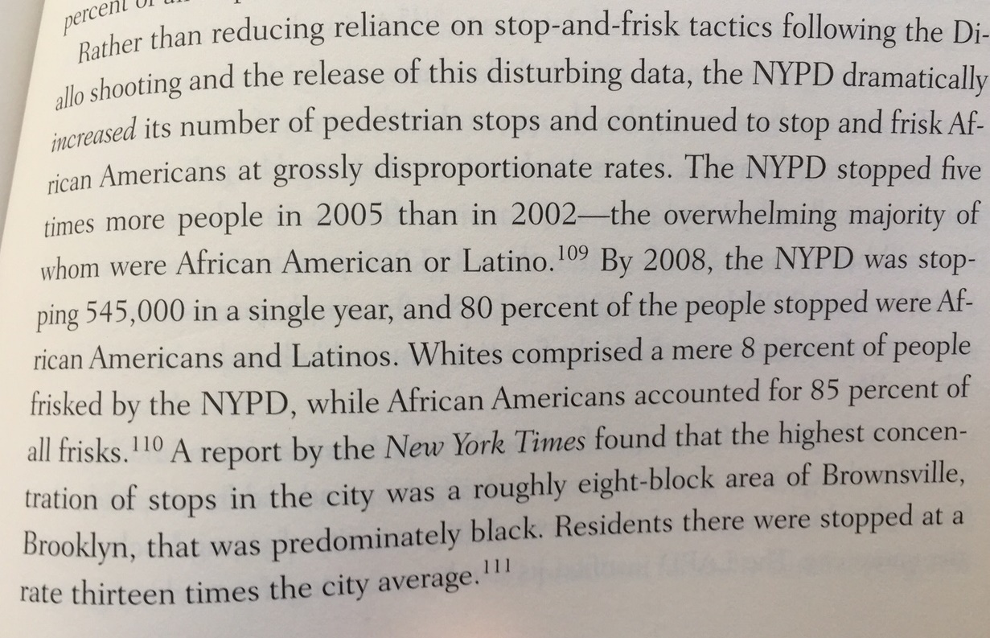

The New Jim Crow pg. 1-4 NOTES:
- Jarvious Cotton’s family tree shows a story of different generations of Black men who cannot vote because of rules in society.

WHO | REASON CANNOT VOTE
Cotton’s great-great grandfather | He was a slave.
Cotton’s great-grandfather | Ku Klux Klan scared and beat him to death.
Cotton’s grandfather | Ku Klux Klan intimidated (scared) him.
Cotton’s father | Unfair poll taxes and literacy tests.
Jarvious Cotton | He is labeled a felon (criminal).

- The reasons and language for why a large amount of Black citizens cannot vote have changed over time, but the end result is still the same. Black citizens are discriminated in terms of jobs, housing, education, and benefits, just like in the past.

- Once a person is labeled a felon (criminal), you recive the same types of discrimination as a Black man during the Jim Crow era of the 1940s—you cannot vote, you are denied food stamps, denied educational opportunities.

- The central idea the author of this book, Michelle Alexander, is making is that there is still a racial caste system in the United States. Our society still discriminates against Black men, just in different ways than the past.

- The author was happy when Barack Obama was elected as the first African American president, but she also felt really sad that at the same time that young Black men are still subject to unfair police brutality.

- The author, Michelle Alexander, was inspired to become a lawyer because of the civil rights movement of the 1950s and 1960s. She thought she would become a lawyer to help keep improving racial progress.

- However, she realized it was a much bigger issue and problem in our prison system and most people didn’t even know about it. The prison system and our criminal justice systems is extremely racist.

- The author, Michelle Alexander, first began her career at an organization called ACLU and worked to stop employment discrimination. It was during this time her focus changed to the problems in our prison system.

- After she left her job at the ACLU, she started realizing along with other lawyers and advocates, that the prison system unfairly holds a large percentage of Black men and it is a different way to control the rights of Black people just like in the past during the Jim Crow era.

- Even after people are released from prison, they are often denied rights to vote, and have a very discriminated life, just like during the Jim Crow era.

The New Jim Crow Introduction pg. 9-19 NOTES
- One in three young African American men is currently under the control of the criminal justice system (either in prison, on probation, or parole) but mass incarceration is seen as a criminal justice issue instead of a racial or civil rights issue.

- Many civil rights advocates have been focused on other issues such as affirmative action (equity vs. equality put in visual image) rather than focus on the issue that our prisons are being filled with black and brown men.

- When Michelle Alexander first joined the ACLU’s Racial Justice Project, the criminal system was not their priority.

- In January 2008, the Leadership Conference on Civil Rights focused on voting rights, affirmative action, immigration, nominations, education, hate crimes, employment, health, housing, and poverty.

- Even elected leaders of the African American community have frequently overlook criminal justice reform.

- There has been some work done in criminal justice reform—for example civial rights groups around the country have helped oppose discriminatory crack sentencing laws and guidelines, as well as “zero tolerance” policies that effectively funnel youth of color from schools to jails.
- Even with the small amounts of progress being made, there is a lack of appreciation for the how huge the mass incarceration crisis actually is.

- “Imagine if civil rights organizations and African American leaders in the 1940s had not placed Jim Crow segregation at the forefront of their racial justice agenda. It would have seemed absurd, given that racial segregation was the primary vehicle of racialized social control in the United States during that period. This book argues that mass incarceration is, metaphorically, the New Jim Crow and that all those who care about social justice should fully commit themselves to dismantling this new racial caste system.”

- It is possible and quite easy to never even realize the current problems in our criminal justice system and not understand the actual reality of what is happening.

- Some people might think to characterize mass incarceration as a “racial caste system” may see seem absurd and exaggerated.

- The author uses the term racial caste to define a stigmatized racial group locked into an inferior (lower) position by law and custom. Jim Crow and slavery were caste systems, and the author is arguing that our current system of mass incarceration is also a caste system.

- “The larger system of mass incarceration is a system that locks people not only behind actual bars in actual prisons, but also behind virtual bars and virtual walls—walls that are invisible to the naked eye but function nearly as effectively as Jim Crow laws once did at locking people of color into a permanent second-class citizenship. The term mass incarceration refers not only to the criminal justice system but also to the larger web of laws, rules polices, and customs that control those labeled criminals both in and out of prison. Once released, former prisoners enter a hidden underworld of legalized discrimination and permanent social exclusion. They are members of America’s new undercaste.

- We avoid talking about caste in our society because we are ashamed of our racial history. We also avoid talking about race. We avoid talking about class.

- Like Jim Crow (and slavery), mass incarceration operates as a tightly networked system of laws, policies, customs, and institutions that operate collectively to ensure the lower status of a group defined largely by race.

- “Many wonder how a nation that has recently just elected its first black president could possibly have a racial caste system. It’s a fair question… Yet as we shall see in the pages that follow, racial caste systems do not require racial hostility to over bigotry to thrive. They need only racial indifference, as Martin Luther King Jr. warned more than forty-five years ago.”

- “Merely reducing sentence length, by itself, does not disturb the basic architecture of the New Jim Crow. So long as large numbers of African Americans continue to be arrested and labeled drug criminals, they will continue to be relegated to a permanent second-class status upon their release, no matter how much (or how little time) they spend behind bars. The system of mass incarceration is based on the prison label, not prison time.

- Of course there are important difference between mass incarceration, Jim Crow, and slavery—the three major racialized systems of control adopted in the United States to date. Many of the differences show how the systems of racialized social control have managed to evolve and adapt over time.

- “If we continue to tell ourselves the popular myths about racial progress or, worse yet, if we say to ourselves that the problem of mass incarceration is just too big, too daunting for us to do anything about and that we should instead direct our energies to battles that might be more easily won, history will judge us harshly. A human rights nightmare is currently on our watch.”

- The author explains the books is written with the intention to show the broad information and issues with mass incarceration. She admits that many important issues have not received the attention they deserve—for example the book talks little about the unique experience of women, Latinos, and immigrants in the criminal justice system.

- The book is intended to stimulate a much needed conversation about the role of the criminal justice system in creating and perpetuating racial hierarchy in the United States.

- The author ends the book with acknowledging the presence of the New Jim Crow and what it means for the future of civil rights advocacy. She argues only a major social movement can successfully take down the new caste system.

